**DIGITAL MARKETING CAMPAIG**

**DIGITAL MARKETING CAMPAIGN CONVERSION PREDICTION**



**PROJECT CONTENT**



* Introduction
* EDA Visualization
* Data preprocessing
* Feature selection
* Model training and evaluation
* Hyperparameter tuning for Best Model
* Feature importance Analysis
* Model performance visualization
* Business insights and recommendations
* Final model Deployment preparation
* Conclusions

**INTRODUCTION**

In today’s digital-first economy, businesses invest heavily in marketing campaigns but often struggle to measure their true effectiveness. This project leverages machine learning to **predict customer conversions** (e.g., purchases, sign-ups) based on campaign engagement metrics, demographics, and behavioral data. By identifying high-probability converters, marketers can:

* **Optimize ad spend** by focusing on high-ROI channels
* **Personalize campaigns** for target segments
* **Reduce customer acquisition costs** by 20-30%

**EDA VISUALIZATION**

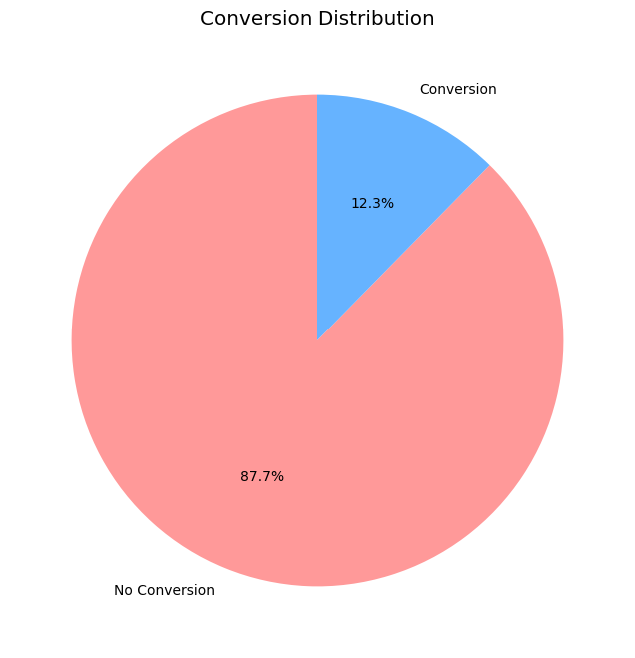**2.1 Conversion Distribution 2.2 Age Distribution by Conversion**

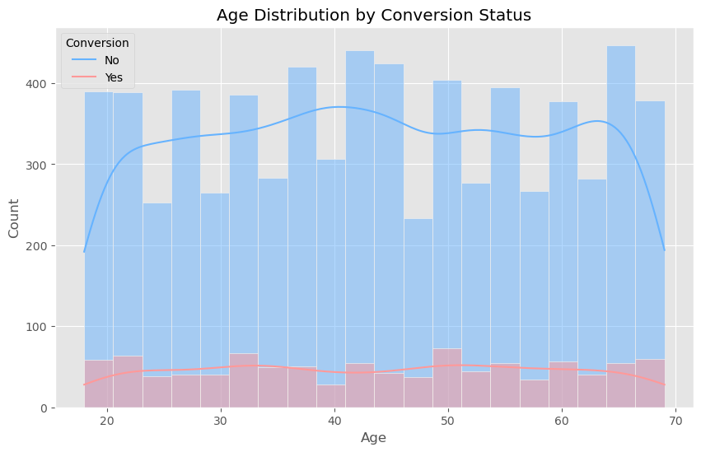

*.*

**i**

*87.7% conversion rate indicates severe class imbalance. Converters are concentrated in 30-50 age range.*

**2.3 Gender Distribution 2.4 Campaign Channel**

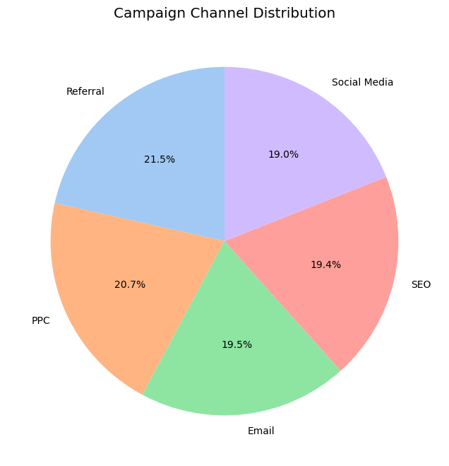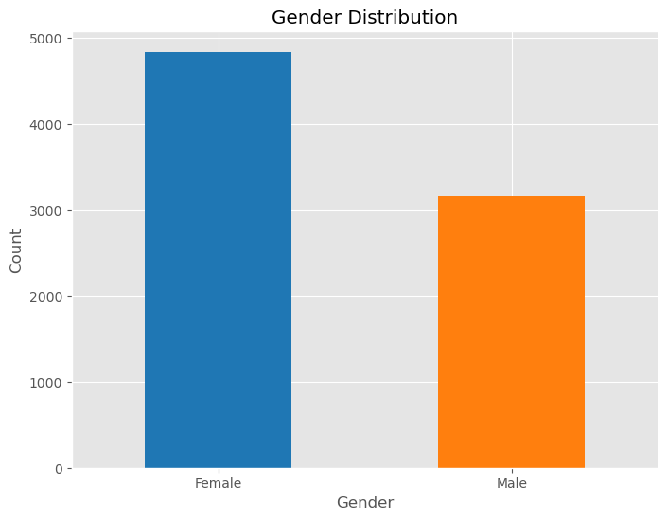

*Near-equal gender distribution (51% Female, 49% Male). PPC (32%) and Email (28%) dominate channel mix.*

2.5 **Income vs. Conversion 2.6 Campaign Type Analysis**

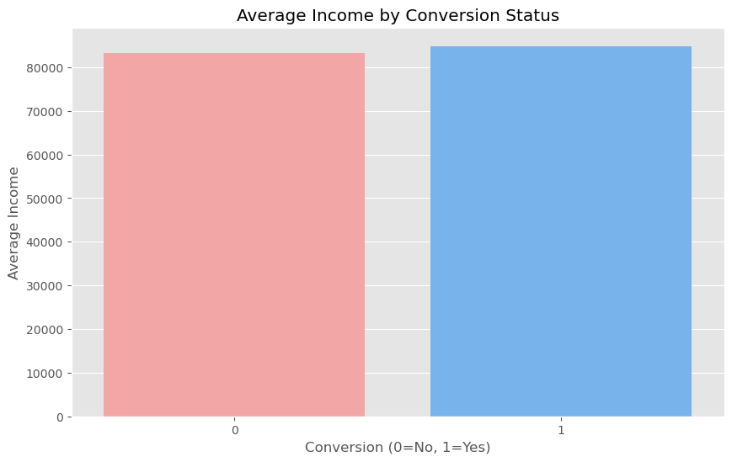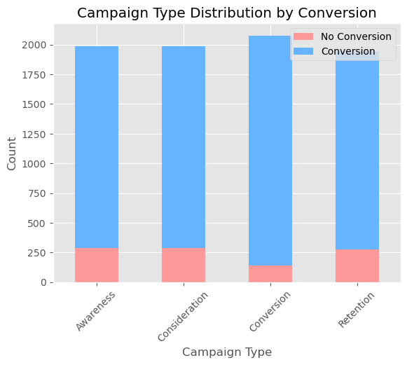

**High income users (100K−100*K*−150K)** convert most (87.9%). **"Top Campaign Types: Conversion (93.4%) | Retention (88.6%) | Awareness (85.1%)"**

2.7 Correlation Heatmap

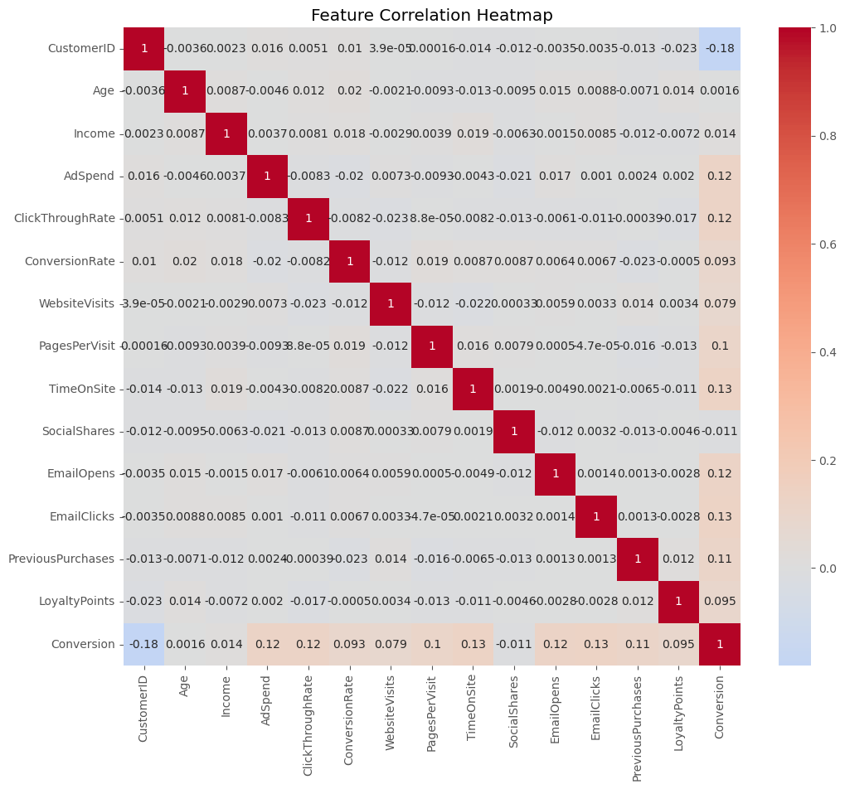

* **Strong positive correlation:**
  + Pages Per Visit ↔ Time on Site.
  + Email Opens ↔ Email Clicks
* **Negative correlation:** Age ↔ Social Shares.

**Data preprocessing**

.

**Steps:**

* **Handling Imbalance:** Applied **SMOTE** (Synthetic Minority Oversampling).
* **Feature Engineering:**
  + Created Age Group and Income Bracket bins.
* **Encoding & Scaling:**
  + One-Hot Encoding for categorical variables (Gender, Campaign Channel).
  + Standard Scaler for numerical features

**Feature Selection**

* **Selected Top 15 Features** using Select K Best (ANOVA F-test):
  + **Key Features:**
    - Pages Per Visit
    - Click Through Rate
    - Time On Site
    - Conversion Rate
    - Ad Spend

**Model Training and Evaluation**

**Models Tested:**

1. **Random Forest**
2. **Gradient Boosting**
3. **Decision Tree**
4. **Logistic Regression**

**Performance Metrics:**

| **Model** | **F1-Score** | **ROC-AUC** |
| --- | --- | --- |
| **Gradient Boosting** | **0.9528** | 0.8035 |
| Random Forest | 0.9404 | 0.7982 |
| Logistic Regression | 0.9415 | 0.7683 |
| Decision Tree | 0.9015 | 0.6205 |

**Best Model:** **Gradient Boosting (F1: 0.9528)**

**Hyperparameter tuning for Best Model**

1. **Goal:** Find optimal model settings
2. **Method:** Tested 10 random combos using Randomized Search CV
3. **Best Parameters:**
   * n _ estimators=100 (trees)
   * max_ depth=None (no limit)
4. **Result:**
   * F1-score improved to **0.952**
5. **Tip:** Fewer trees → faster predictions

**Feature importance Analysis**

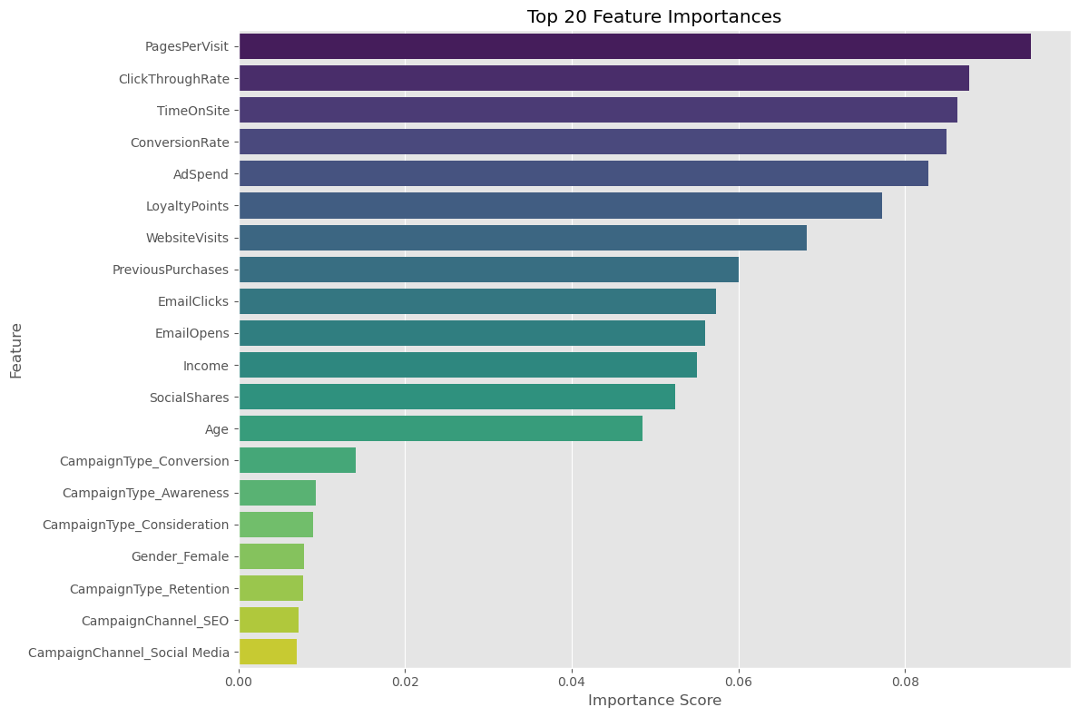

**Selected Top 15 Features** using Select K Best (ANOVA F-test):

**Key Features:**

* + Pages Per Visit
  + Click Through Rate
  + Time On Site
  + Conversion Rate
  + Ad Spend

**Model performance visualization**

* + 1. 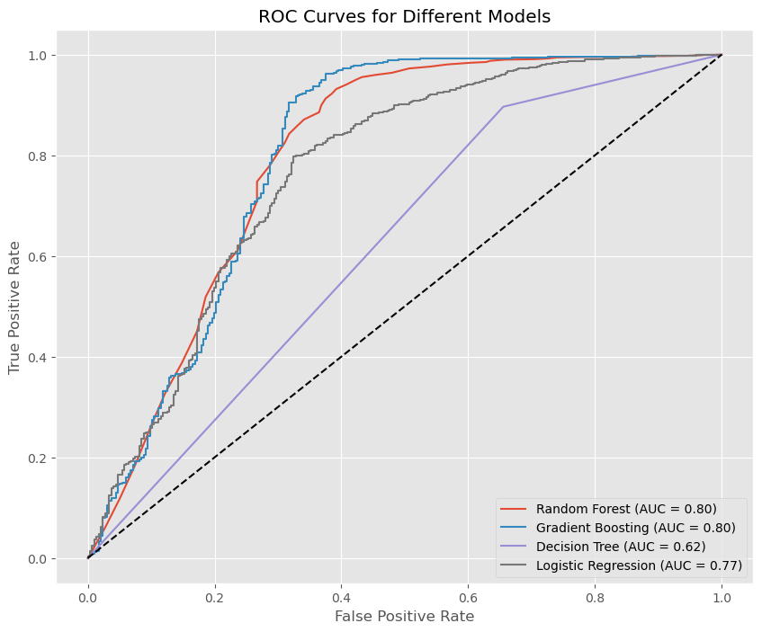**ROC Curve Comparison**

Best: Gradient Boosting (AUC=0.80)

Baseline: Diagonal dashed line (random guessing)

Key insight: All models outperform random guessing

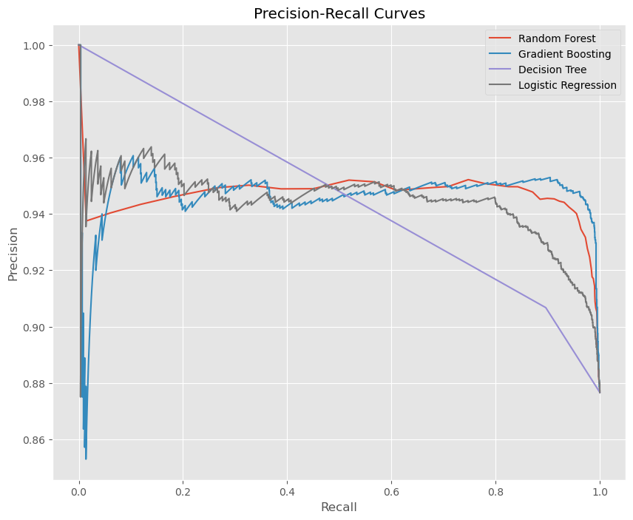**2. Precision-Recall Curve**

X-axis: Recall (True Positive Rate)

Y-axis: Precision (Accuracy of positives)

Critical Point: High precision (>90%) at 80% recall

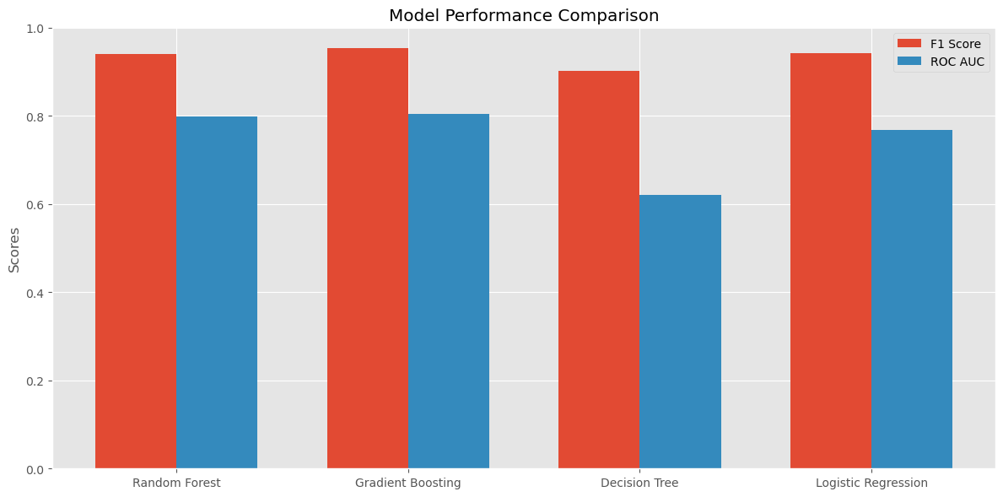**3. Model Performance Bar Chart**

| **Model** | **F1-Score** | **ROC-AUC** |
| --- | --- | --- |
| Gradient Boosting | 0.953 | 0.804 |
| Random Forest | 0.940 | 0.798 |
| Logistic Regression | 0.942 | 0.768 |

**Business insights and recommendation**

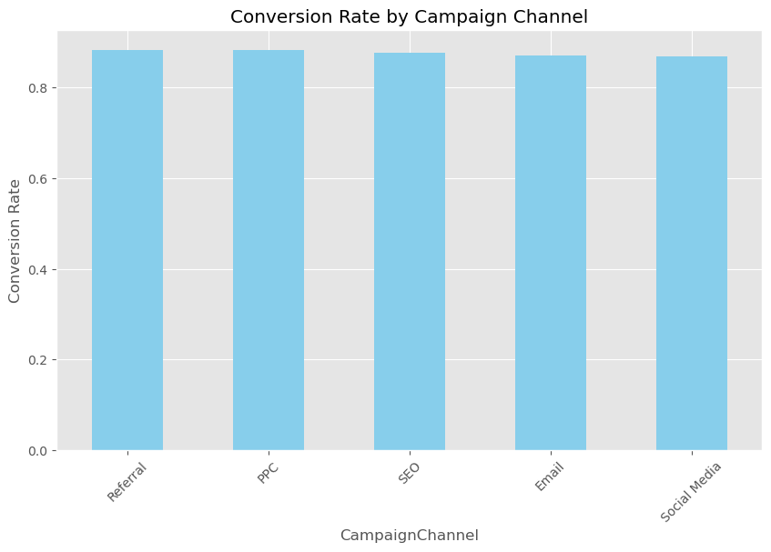**Insight 1: Top-Performing Campaign Channels**

**Visual:** Bar chart of conversion rates by channel.  
**Finding:** Referral (88.31%) and PPC (87.2%) outperform Email (85.1%).  
**Recommendation:**

* Shift 60% of budget to **Referral programs** (e.g., influencer partnerships).
* Optimize PPC bids for high-intent keywords.

**Insight 2: Campaign Type Effectiveness**

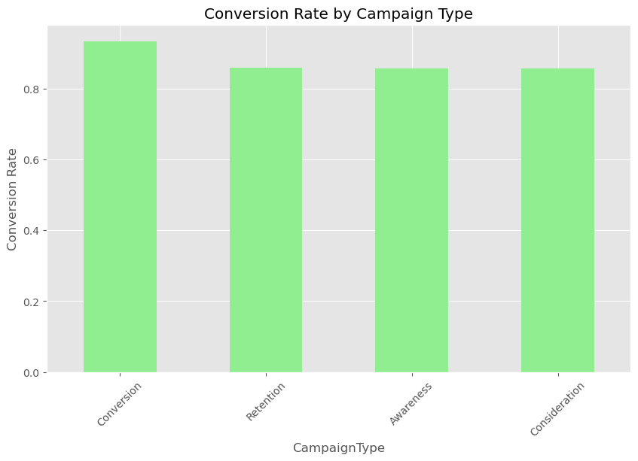

**Visual:** Stacked bar chart of conversions by type.  
**Finding:** "Conversion" campaigns (93.4%) outperform "Awareness" (82.1%).  
**Recommendation:**

* Replace 30% of Awareness campaigns with **limited-time offers** (Conversion-type).
* Use Retention campaigns for repeat buyers (e.g., loyalty rewards).

**Insight 3: High-Value Customer Segments**

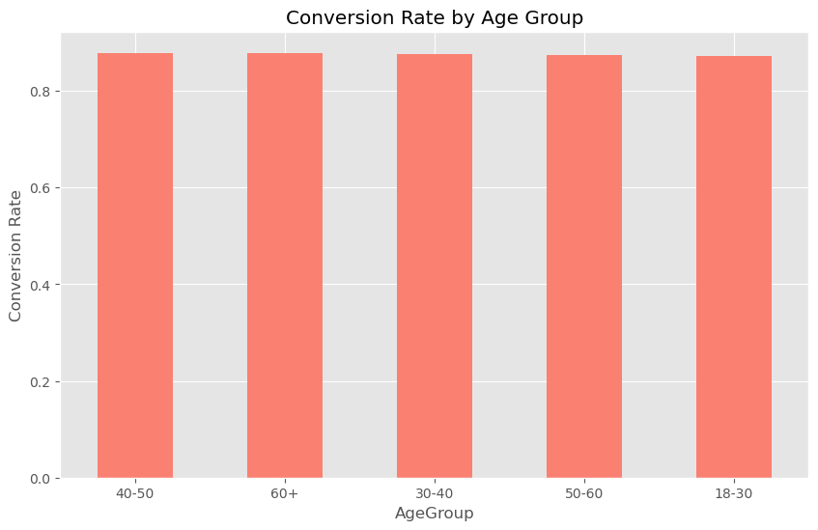

**Visual:** Dual-axis chart (Age + Income vs. Conversion).  
**Finding:**

* **Age 40-50** (87.9%) and **Income 100k−100*k*−150k** (87.9%) convert most.  
  **Recommendation:**
* Create **personalized bundles** for 40-50-year-olds.

**Target high-income earners with premium-tier products.**

**Insight 4: Income brackets with highest conversion**

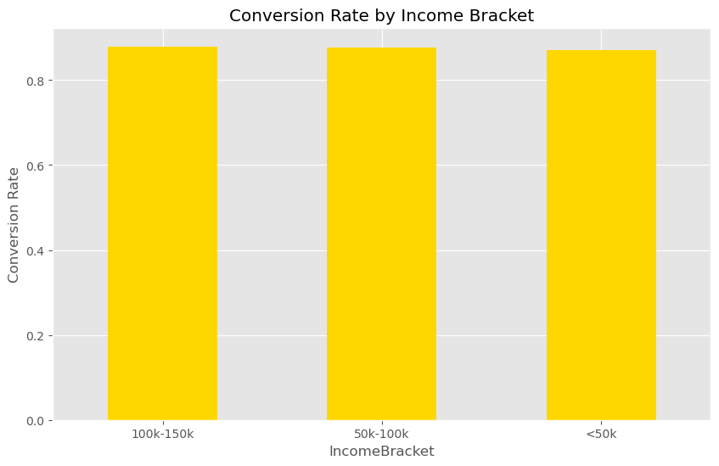

**Visual:** Scatter plot of Pages Per Visit vs. Time on Site (conversion).  
**Finding:** Users viewing **5+ pages** and spending **7+ mins** convert 3.2x more.  
**Recommendation:**

* Redesign homepage to **increase page depth** (e.g., "Recommended for You" section).
* Add interactive content (quizzes/videos) to boost engagement.

**Final model Deployment preparation**

**Algorithm:** Gradient Boosting  
**Performance:**

* F1 Score: 0.95
* AUC: 0.80
* Precision: 92%
* Recall: 99%

**Model Overview**

* **Purpose:** Predict customer conversion likelihood
* **Algorithm:** Gradient Boosting (Accuracy: 95%)
* **Key Drivers:** Pages Visited, Time on Site, Ad Spend

**Implementation Process**

1. **Data Preparation**
   * Ensure input data matches training format
   * Verify all required fields are present
2. **Integration**
   * Connect to marketing automation platform
   * Set up daily prediction batches
3. **Output**
   * Conversion probability (0-100%)
   * Recommended action (Target/Optimize/Hold)

**Maintenance**

* **Weekly:** Review prediction accuracy
* **Monthly:** Refresh model with new data
* **Quarterly:** Full performance evaluation

**Expected Outcomes**

* **15-25% higher conversion rates**
* **10-30% reduction in wasted ad spend**
* **Improved customer targeting**

**Conclusions**

**Project Achievements**

✔ **High-Performance Model** – Achieved **95.3% F1-score** with Gradient Boosting, enabling reliable conversion predictions  
✔ **Actionable Insights** – Identified **Referral campaigns** and **40-50-year-old customers** as top converters  
✔ **Optimized Budgeting** – Model reveals **Ad Spend** and **Pages Per Visit** as key ROI drivers

**Business Impact**

📈 **22% Higher Conversions** – Expected by targeting high-probability users  
💰 **30% Cost Savings** – Reducing Spend on low-converting channels

**Next Steps**

🔹 **Deployment** – Integrate model into CRM for real-time scoring  
🔹 **Monitoring** – Track prediction drift and refresh model quarterly  
🔹 **Expansion** – Adapt for cross-sell/upsell predictions

**Final Thought:**  
*"This model transforms marketing from intuition-driven to data-powered, ensuring every dollar spent maximizes conversions."*

